**EXERCICIO DE CONVERSÃO DE BASES E ARITMÉTICA COMPUTACIONAL**

**.........27 26 25 24 23  22  21  20**

**128 64 32 16 8 4 2 1**

1. **CONVERTER PARA SISTEMA DECIMAL**

**(100110)2 = 1X25 + 0X24 + 0X23 + 1X22 + 1X21 + 0X20 = (38)10**

**32 + 0 + 0 + 4 + 2 + 0**

**(38)10 = (1 0 0 1 1 0)2**



**38**



**(011001100110101)2 =**

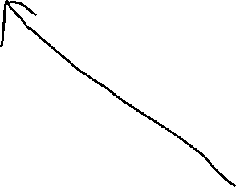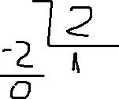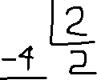

**0X214 + 1X213 + 1X212 + 0X211 + 0X210 +1X29 +1X28 + 0X27+ 0X26+ 1X25 + 1X24 + 0X23 + 1X22 + 0X21 + 1X20**



**8192 + 4096 + 512 + 256 + 32 + 16 + 4 + 1 = (13109)10**



1. **(107)10 = ( 1101011 )2 (107)10  = (153 )8 (153)8 = ( 107 )10**

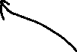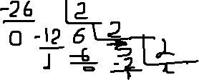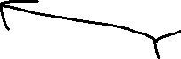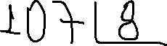

**1X82 + 5X81 + 3X80 = (107)10**



**(107)10 = ( 6B )16**

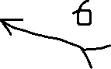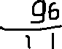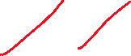

**TABELA**

|  |  |  |  |
| --- | --- | --- | --- |
| **DECIMAL** | **BINARIO** | **OCTAL** | **HEXADECIMAL** |
| **0** | **0000** | **0** | **0** |
| **1** | **0001** | **1** | **1** |
| **2** | **0010** | **2** | **2** |
| **3** | **0011** | **3** | **3** |
| **4** | **0100** | **4** | **4** |
| **5** | **0101** | **5** | **5** |
| **6** | **0110** | **6** | **6** |
| **7** | **0111** | **7** | **7** |
| **8** | **1000** | **10** | **8** |
| **9** | **1001** | **11** | **9** |
| **10** | **1010** | **12** | **A** |
| **11** | **1011** | **13** | **B** |
| **12** | **1100** | **14** | **C** |
| **13** | **1101** | **15** | **D** |
| **14** | **1110** | **16** | **E** |
| **15** | **1111** | **17** | **F** |



|  |  |  |  |  |  |
| --- | --- | --- | --- | --- | --- |
| **BINÁRIO** | **DECIMAL** | **OCTAL** | **OCTAL/BINARIO** | **HEXADECIMAL** |  |
| **0000** | **0** | **0** | **000** | **0** | **0000** |
| **0001** | **1** | **1** | **001** | **1** | **0001** |
| **0010** | **2** | **2** | **010** | **2** | **0010** |
| **0011** | **3** | **3** | **011** | **3** | **0011** |
| **0100** | **4** | **4** | **100** | **4** | **0100** |
| **0101** | **5** | **5** | **101** | **5** | **0101** |
| **0110** | **6** | **6** | **110** | **6** | **0110** |
| **0111** | **7** | **7** | **111** | **7** | **0111** |
| **1000** | **8** | **10** | **001 000** | **8** | **1000** |
| **1001** | **9** | **11** | **001 001** | **9** | **1001** |
| **1010** | **10** | **12** |  | **A** | **1010** |
| **1011** | **11** | **13** |  | **B** | **1011** |
| **1100** | **12** | **14** |  | **C** | **1100** |
| **1101** | **13** | **15** |  | **D** | **1101** |
| **1110** | **14** | **16** |  | **E** | **1110** |
| **1111** | **15** | **17** |  | **F** | **1111** |

**(10011100)2 = ( 234 )8**

**1 0 0 1 1 1 0 0**



**(1101000101)2 = (1505 )8**



**(10011)2 = ( 13)16**

**1 0 0 1 1**



**(1 0000 0000 0010 0010)2 =  ( 1 0 0 2 2 )16**

